[brian09088](https://github.com/brian09088) / [Yuanta-API](https://github.com/brian09088/Yuanta-API)

Public

[Code](https://github.com/brian09088/Yuanta-API) [Issues 2](https://github.com/brian09088/Yuanta-API/issues) [Pull requests](https://github.com/brian09088/Yuanta-API/pulls) [Actions](https://github.com/brian09088/Yuanta-API/actions) [Projects 1](https://github.com/brian09088/Yuanta-API/projects) [Security](https://github.com/brian09088/Yuanta-API/security) [Insights](https://github.com/brian09088/Yuanta-API/pulse) [Se](https://github.com/brian09088/Yuanta-API/settings)

[Yuanta-API](https://github.com/brian09088/Yuanta-API/tree/main) / README.md



[brian09088](https://github.com/brian09088/Yuanta-API/commits?author=brian09088) yesterday

49 lines (40 loc) · 2.48 KB

Preview Code Blame



Yuanta-API **元⼤期貨交易**API**串接與⾃動化交易**

# !!! 注意檔案⽬錄安裝路徑要正確，否則容易出現報錯

程式檔案存放位置(C:/Yuanta/QAPI)

vs-code 終端機預設⽬錄(C:/Users/User)下⽅存放wxPython.whl檔案

anaconda 要看⾃⼰安裝的位置，去設定python-32bits環境

======

開⼾階段-選擇⾝分別為保險公司-可以拿到⾏情API權限

!⼀般⽤⼾(⾃營商交易帳⼾)-無法取得權限，只能透過API下單與看盤軟體[例如:元⼤點⾦靈](https://www.yuanta.com.tw/eYuanta/securities/aporder/Instructions/836878aa-5e5f-4dc8-9d18-984e9bf5c1cd?TargetId=16b7b99c-7cc5-4b05-9208-58f026f8da0a&TargetMode=2)下單

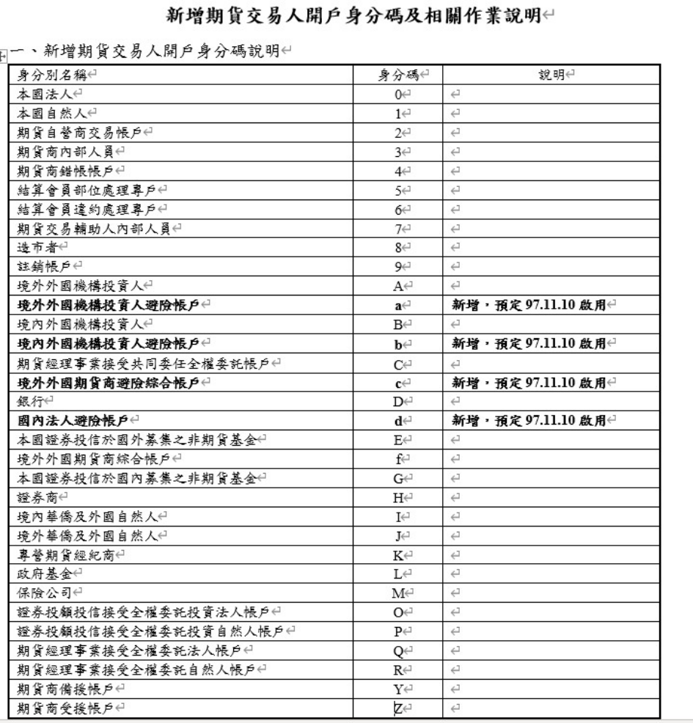

# 環境設定:

python3.9 anaconda 64-bits

create python 32-bits environment

開啟anaconda prompt, 輸入以下指令創建新環境

詳情可看(<https://www.youtube.com/watch?v=o1Zzw-Y_n2g>)

set CONDA_FORCE_32BIT=1 #名稱⾃定set #開始建置

conda create -n ENV_32BIT #建立環境

activate ENV_32BIT #啟動新環境，繼續在環境中安裝

conda install python=3.9 #於新環境中設置python3.9，由於api中套件wx,comtypes⽀援3.9以下版本

可以打開C:\anaconda\envs\ENV_32BIT\python.exe，成功顯⽰python=3.9

download wxpython 32-bits [(https://files.pythonhosted.org/packages/05/d1/40ca8bacba94d49d3c379a0ea0220cb9594f459 78a40c321a46d4727d93e/wxPython-4.1.1-cp39-cp39-win32.whl)](https://files.pythonhosted.org/packages/05/d1/40ca8bacba94d49d3c379a0ea0220cb9594f45978a40c321a46d4727d93e/wxPython-4.1.1-cp39-cp39-win32.whl)

install comtypes (do it in anaonda prompt : conda install -c free comtypes) activigate jupyter or spyder or vs-code, for running Yuantaapi.py

after install wxpython 32-bits, move whl file to vs-code terminal directory (C:\Users\User) open Yuantaapi.py through anaconda in vs-code and type in vs-code terminal

pip install wxPython-4.1.1-cp39-cp39-win32.whl

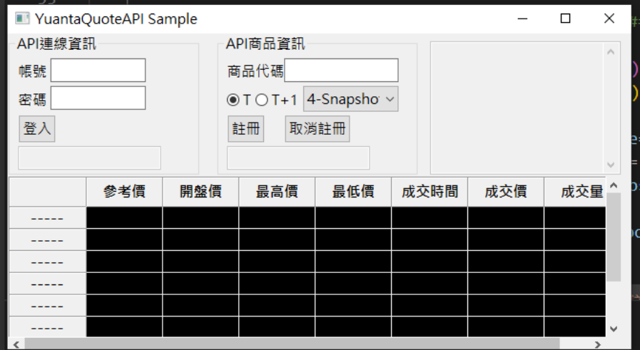執⾏後跳出登入視窗如下圖所⽰

輸入元⼤期貨帳⼾與交易密碼

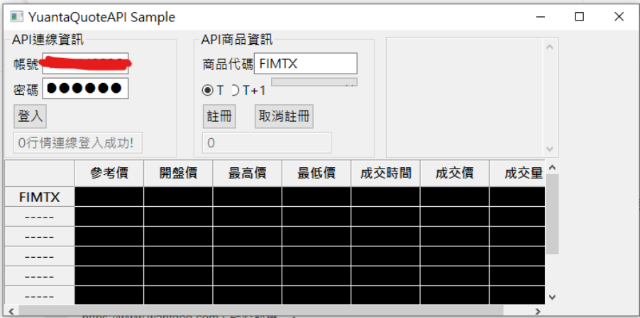右欄註冊區輸入產品代碼[元⼤期貨下單商品代碼規則](https://www.multicharts.com.tw/dis/dis_Content.aspx?D_ID=3&SN=5120)成功連線與註冊

商品註冊成功

